Free Youtube views for an unlimited number of your videos! Boost your video's popularity using their simple and free method! Or, buy Youtube views and other services here.

[ythunder.com](https://ythunder.com/) has free & open registrations.

You don’t have to be a movie or TV star to be famous anymore.

In today’s digital world, anyone can make a name for themselves online with the right content. One of the easiest ways to attract attention for your personal or professional brand is to go on Free Youtube views：[ythunder.com](https://ythunder.com/)

[YouTube](https://ythunder.com/) and broadcast yourself to the world.

After all, [YouTube](https://ythunder.com/) has a phenomenal 1.9 billion monthly users. That’s a

Learning how to broadcast yourself on [YouTube](https://ythunder.com/) gives you an instant channel through which to connect with your target audience. Once you’ve figured out how to use the power of video to your advantage, you can create virtually any kind of material you like, including Q&A sessions, how-to videos,and even product promotions.

Of course, to get started with the [YouTube](https://ythunder.com/) broadcast yourself experience, you need to know the basics. That’s why we’re here to help.

**[YouTube](https://ythunder.com/) - Broadcast Yourself, Live or Static?**

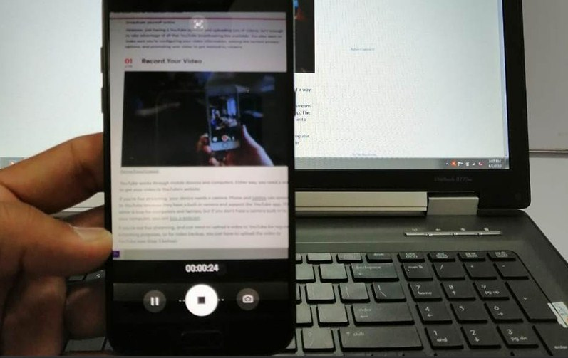

There are two different ways that you can use [YouTube](https://ythunder.com/) to Free Youtube views：[ythunder.com](https://ythunder.com/)

broadcast yourself to the masses.

The first option is to use a traditional video upload. Thissimply means that you use [YouTube](https://ythunder.com/) as a social platform, where you can upload videos that you’ve already created and edited. This kind of broadcasting is excellent if you’re concerned about the image you’re putting out into the world.

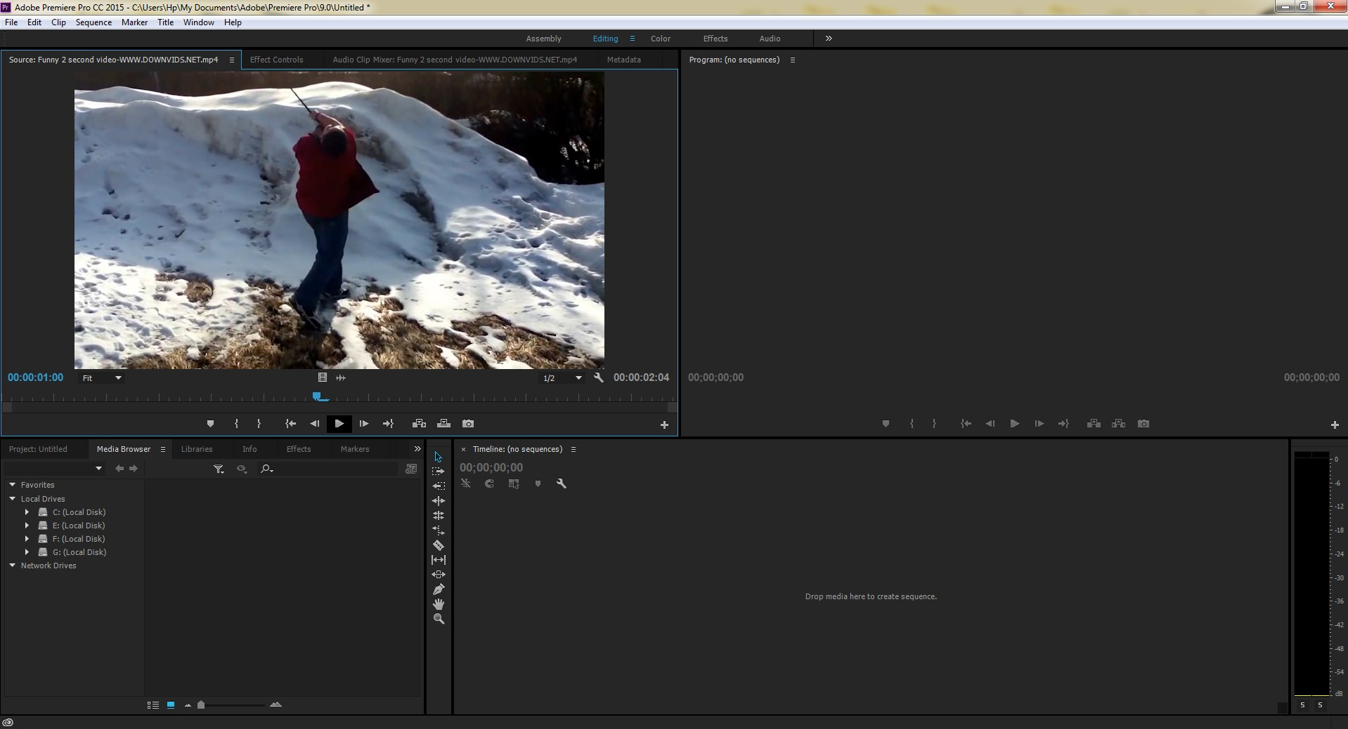

With a pre-edited video, you can make sure that you haven’t made any mistakes that might harm your reputation.

On the other hand, you’ve got live-streaming – one of the most valuable content marketing strategies in the world today.

The stats about live streaming speak for themselves. According to the IAB, 47% of live streaming video viewers around the world are streaming more content today than they were a year ago. What’s more, this kind of video allows you to develop an authentic relationship with your audience through raw – uncut content.

Whichever kind of [YouTube](https://ythunder.com/) broadcast yourself experience you’re looking for, you’re going to need an account. Go ahead and sign up for a profile now and fill out your information. If you’ve got a Gmail account, then you can sign up for [YouTube](https://ythunder.com/) through that.

**How to Upload Static Video**

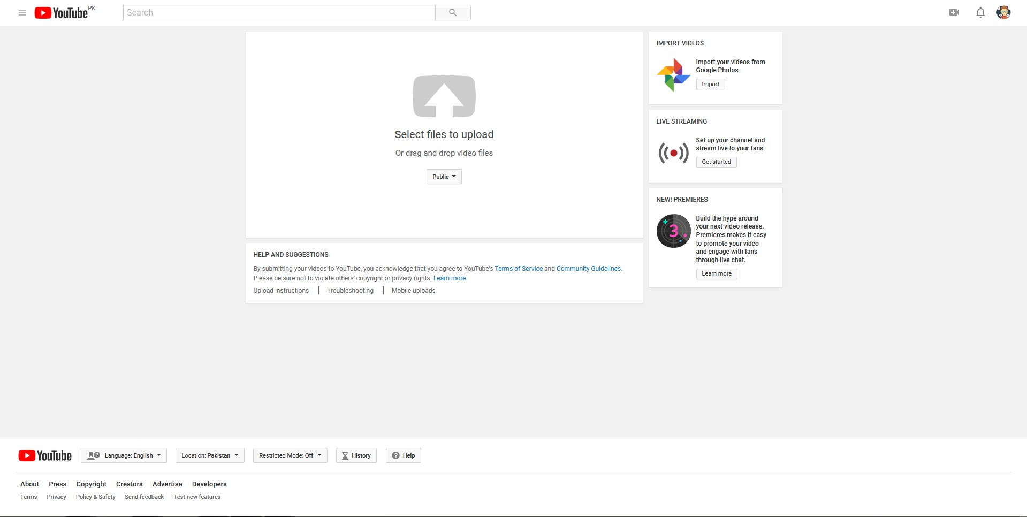

If you decide that you want to stick to static video for now, here’s what you need to do. First of all, go and pick a high-quality camera that you can use to create your content. While you can always edit your pre-created videos before you put them on [YouTube](https://ythunder.com/), you’ll still need a good camera if you want a high frame-rate and good image capture.

You’ll also need a microphone so that you can speak to your audience. Some people decide to just use music over their videos instead of speaking. If you choose to do this, it’s fine, but it’s best to have a microphone available in case you change your mind. Avoid simply creating your content on your smartphone, as this often looks unprofessional. Remember that people will expect a higher quality of video from something that you’re not streaming live.

**Publishing Your Video**

Once you’re ready to upload your video, make sure that it looks as good as you think it does. There’s plenty of video editing software out there that you can use to add voiceovers or music to parts of your content. You can even remove bits that don’t work with your brand image. Just remember to check that you’re using an editing system that delivers content [YouTube](https://ythunder.com/) can publish. Before you begin your You Tube broadcast yourself journey, check the supported file format page.

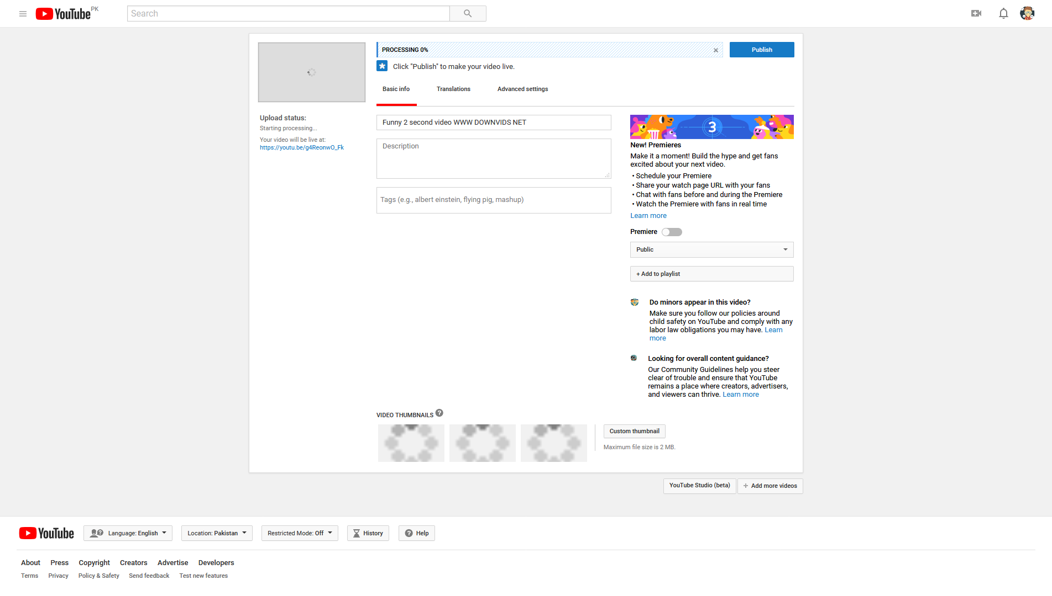

Some points to remember:

* Video files can only be 12 hours in length or up to 128GB for verified accounts
* Video limits are fifteen minutes for non-verified accounts
* Your video should be synced into the highest possible quality
* Compress your video to make it easier to load to [YouTube](https://ythunder.com/)
* You can upload your videos to [YouTube](https://ythunder.com/) through your mobile app or desktop browser.

**Entering Your Information for** [**YouTube**](https://ythunder.com/)

In the [YouTube](https://ythunder.com/) mobile app, search for the camera icon at the top of the page to upload your existing video. You’ll be able to do the same thing on your computer if you’re logged into your account. Remember, [YouTube](https://ythunder.com/) needs to process the entire video before anyone sees it. You’ll also need to adjust the privacy settings to determine who will view your content.

While you wait for the video processing to be complete, enter all the information required about your material in the text fields. You’ll need to complete:

* Basic info: Describe your video, add a title, and remember to include keywords that you want to rank for. This will make your video visible to the people searching for it.
* Set a thumbnail for your video: You can configure a custom thumbnail, or simply allow [YouTube](https://ythunder.com/) to pull one from your content automatically.
* Set your privacy: There are three privacy options available: Private, which is only for you, Unlisted, which means that it can be found with an URL but nothing else, and Public. If you want the best reach for your content, you’ll need to choose Public

Once you’re done with the basic info, go to the Advanced settings page to disable or enable comments for your video, and turn ratings on or off. You can also submit your new content to a specific category on [YouTube](https://ythunder.com/) too.

**[YouTube](https://ythunder.com/) - Broadcast Yourself Live**

Now you know how to upload a static video, what if you want to go on [YouTube](https://ythunder.com/) to Broadcast yourself live instead? Well, you’ll still need a camera or microphone, but in this case, you can use your smartphone and tablets to stream directly to the [YouTube](https://ythunder.com/) app. It’s also possible to buy a camera or webcam separately, just make sure it connects to the computer you’re using.

Remember, with live streaming; your video won’t have to be quite as perfect as it would need to be with a standard upload. People expect live videos to be raw and authentic. However, that doesn’t mean you shouldn’t concentrate on quality. Choose a high-pixel camera if you can.

**Logging into Live Video**

To broadcast yourself with live video on [YouTube](https://ythunder.com/), you’ll need to go to the [YouTube](https://ythunder.com/) Live dashboard. Click on the profile picture for your channel to access your settings and go to the Creator Studio button, then choose the “Live Streaming” tab.

If you’re new to live streaming, you’ll have to select the Get Started button at the top of the page. In this section, you’ll need to enter information like:

* Your country
* Your phone number
* The title for your stream

[YouTube](https://ythunder.com/) will also send you a verification code that you’ll need to enter into your profile. Unfortunately, you do have to wait 24 hours after entering this code to get access to your [YouTube](https://ythunder.com/) broadcast features. Once that time has passed, you can log into your account again with most browsers to begin your live stream. To get started:

* Click on Go Live
* Allow [YouTube](https://ythunder.com/) to access your camera and microphone
* Enter a name for your stream in the Title box
* Select a privacy setting for your viewers (Public, private or unlisted)
* Click Next
* Snap a thumbnail with [YouTube](https://ythunder.com/) (You can re-take the image by clicking on Retake Thumbnail)
* Hit Go Live again

That’s it! You’re ready to [YouTube](https://ythunder.com/) broadcast yourself to a live audience.

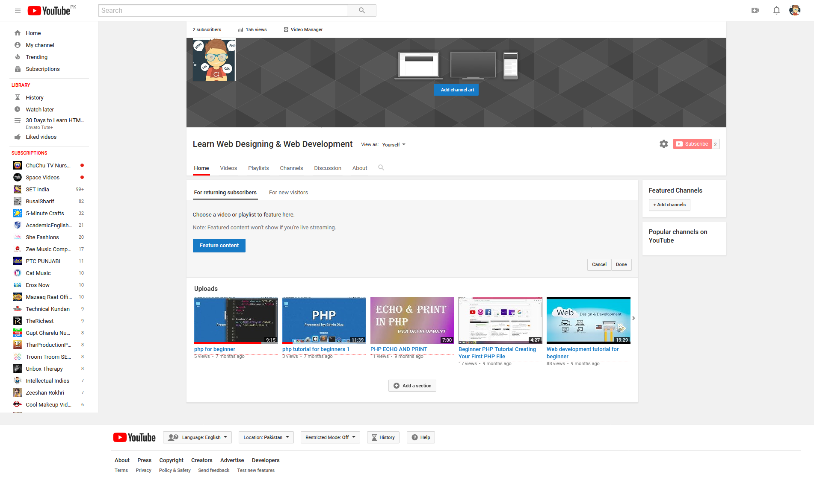

**How to Make the Most of your Broadcast Experience**

While learning how to [YouTube](https://ythunder.com/) broadcast yourself is an excellent way to gain attention online and build a reputation for your brand, it takes some time and effort to get the most out of the experience. Ultimately, you can’t expect to just post the occasional video or run the odd live stream and see people rushing to your account. Instead, you need to take some time to advertise your videos.

Start by customizing your [YouTube](https://ythunder.com/) channel, update your images and text to reflect the unique nuances of your personality, and make sure that your bio lets visitors know when they can expect to see new videos and streams from your brand. Once you’ve done that:

* Promote your streams on other social media platforms: If you have a Facebook, Instagram, or Twitter following, let them know about your upcoming video a week or so in advance. Count down to the big day and let them know what they can expect when they get there. You can even offer gifts and voucher codes to get people moving.
* Collaborate with influencers: Connect with other people in your industry to improve your chances of reaching as many people as possible. Influencers can act as a launching pad, capable of transforming your entire strategy.
* Optimize your videos: Video title tags, keywords, and a great thumbnail can all improve your chances of being found when you post your next video. You can even start a blog for your videos where you link back to your [YouTube](https://ythunder.com/) profile.

Remember, your [YouTube](https://ythunder.com/) broadcast yourself experience can do amazing things for your brand, but only if you’re willing to do the work.Free Youtube views for an unlimited number of your videos! Boost your video's popularity using their simple and free method! Or, buy Youtube views and other services here.

[ythunder.com](https://ythunder.com/) has free & open registrations.